Sri Lanka Institute of Information

Technology



Lab Submission

Lab sheet No 9

**IT24101293**

**Dissanayake GRTC**

**Probability and Statistics| IT2120**

B.Sc. (Hons) in Information Technology

**Exercise**

Q1

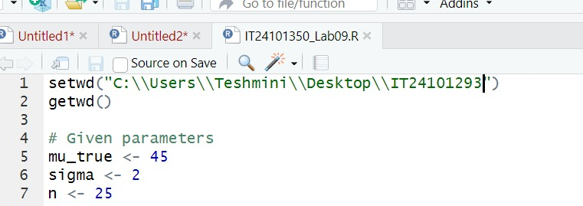

i)

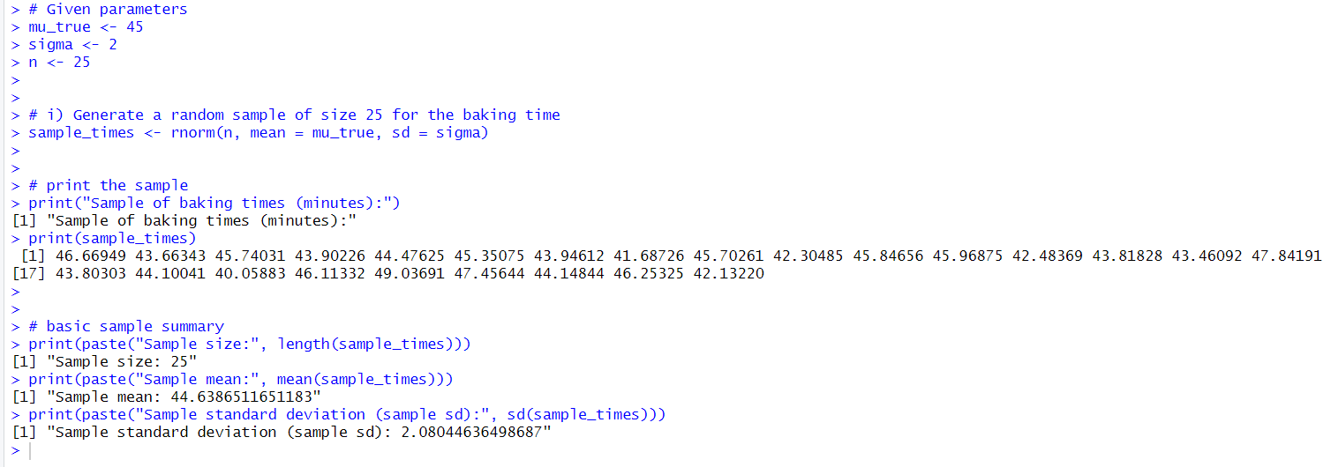

ii)

